Step 1
Manage Jenkins → Credentials → System → Global Credentials → Add Credentials
Choose:
- Kind: Username with password
- Scope: Global
- Username: your-dockerhub-username
- Password: Paste the Docker Hub Access Token
- ID: docker-cred
- Description: Docker Hub Token
Then click Create.
Your screen should look like this:
- Username: denitjoseph
- Password: Docker Hub Access Token or password of docker
- ID: docker-cred
- Description: Docker Hub Token
Step 2
Manage Jenkins → Credentials → System → Global Credentials → Add Credentials
Choose:
- Kind: Username with password
- Scope: Global
- Username: your-github-username
- Password: Paste the git Hub Access Token
- ID: github
- Description: Git Hub Token
Then click Create.
Your screen should look like this:
- Username: denitjoseph
- Password: Git Hub Access Token or password of docker
- ID: github
- Description: Git Hub Token
there are some changes in the script like change the user name of docker and git hub (change the user name of yours )
Kubernetes
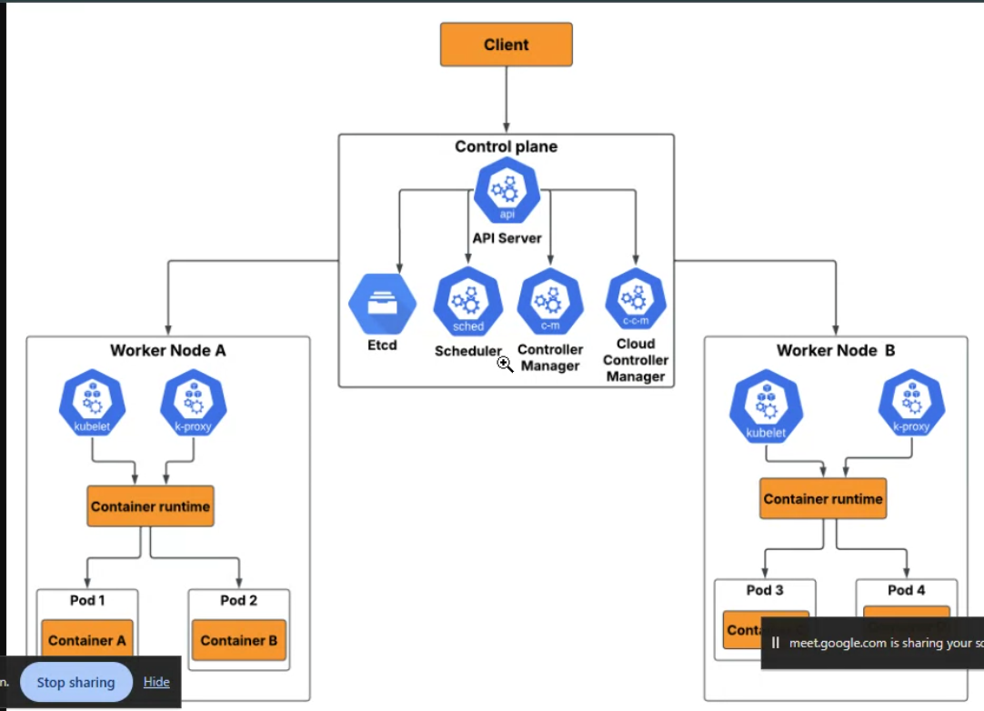
Overall Architecture
There are three main parts:
- Client
- Control Plane (Master Node)
- Worker Nodes

1. Client
The Client is where users or developers interact with Kubernetes.
Examples:
- kubectl command-line tool
- Kubernetes Dashboard
- CI/CD tools
When you run a command like:
kubectl apply -f deployment.yaml
the request goes to the API Server.

2. Control Plane (Master Node)
The Control Plane is the brain of Kubernetes. It decides what should happen in the cluster.
API Server
- Entry point for all Kubernetes requests.
- Receives commands from users.
- Validates requests.
- Updates the cluster state.
Example:
kubectl create deployment nginx
The request first reaches the API Server.

Etcd
Etcd is Kubernetes' database.
It stores:
- Cluster configuration
- Node information
- Pod information
- Secrets
- ConfigMaps
Think of it as:
Cluster Memory
Whenever the API server changes something, it saves it in etcd.

Scheduler
The Scheduler decides:
Which worker node should run a new pod?
It checks:
- Available CPU
- Available memory
- Node health
- Affinity/anti-affinity rules
- Taints and tolerations
Example:
You create 3 pods.
Scheduler decides:
Pod1 → Worker A
Pod2 → Worker B
Pod3 → Worker A

Controller Manager
Controllers constantly watch the cluster and make sure the actual state matches the desired state.
Example:
Desired:
3 Pods
Actual:
Only 2 Pods are running
Controller Manager notices this and creates the missing pod automatically.
It handles:
- Deployment Controller
- ReplicaSet Controller
- Node Controller
- Job Controller

Cloud Controller Manager
Used when Kubernetes runs in cloud environments like:
- AWS
- Azure
- Google Cloud
It manages cloud resources such as:
- Load Balancers
- Storage volumes
- Cloud networking
- Node lifecycle

3. Worker Nodes
Worker nodes are the machines where your application actually runs.
Each worker node contains:
- Kubelet
- Kube-Proxy
- Container Runtime
- Pods

Kubelet
Kubelet is the agent running on every worker node.
Responsibilities:
- Receives instructions from the API Server.
- Starts containers.
- Monitors pod health.
- Reports node and pod status back to the Control Plane.
Example:
API Server:
Run Pod A
Kubelet:
Starts Pod A using the container runtime.

Kube-Proxy
Kube-Proxy manages networking.
Responsibilities:
- Enables communication between pods.
- Handles Services.
- Load balances traffic to pods.
Example:
Suppose you have:
Service
|
------------
| | |
Pod1 Pod2 Pod3
Kube-Proxy distributes incoming requests among the available pods.

Container Runtime
The Container Runtime actually runs containers.
Examples:
- containerd (most common today)
- CRI-O
Responsibilities:
- Pull container images
- Start containers
- Stop containers
- Manage container lifecycle

Pods
A Pod is the smallest deployable unit in Kubernetes.
A pod contains:
- One or more containers
- Shared networking (same IP)
- Shared storage (volumes)
In your diagram:
Worker Node A:
Pod1
└── Container A

Pod2
└── Container B
Worker Node B:
Pod3
└── Container C

Pod4
└── Container D

How Everything Works Together
Imagine you deploy an application with 4 replicas:
Step 1
User runs:
kubectl apply -f deployment.yaml
↓
Step 2
API Server receives the request.
↓
Step 3
API Server stores the desired state in etcd.
↓
Step 4
Scheduler selects the best worker node for each pod.
↓
Step 5
Kubelet on each selected worker node receives instructions.
↓
Step 6
Container Runtime pulls the required Docker image and starts the containers.
↓
Step 7
Pods begin running on Worker Nodes.
↓
Step 8
Kube-Proxy configures networking so users can reach the application.
↓
Step 9
Controller Manager continuously monitors the cluster. If a pod crashes, it automatically creates a replacement to maintain the desired number of replicas.

Summary Table
Component | Purpose
Client | Sends commands to Kubernetes (e.g., kubectl)
API Server | Entry point for all cluster operations
Etcd | Stores the cluster's desired and current state
Scheduler | Assigns new pods to suitable worker nodes
Controller Manager | Keeps the actual state aligned with the desired state
Cloud Controller Manager | Integrates Kubernetes with cloud provider services
Worker Node | Runs application workloads
Kubelet | Ensures pods are running on the node
Kube-Proxy | Handles networking and service traffic
Container Runtime | Runs and manages containers
Pod | Smallest deployable unit that contains one or more containers
A useful analogy is to think of Kubernetes as a logistics company:
- Client = Customer placing an order.
- API Server = Customer service receiving the order.
- Etcd = Central database storing order details.
- Scheduler = Dispatcher assigning work to delivery trucks.
- Controller Manager = Supervisor ensuring every order is fulfilled.
- Worker Nodes = Delivery trucks doing the work.
- Kubelet = Driver following the dispatcher's instructions.
- Container Runtime = Engine that powers the truck.
- Pods = The packages being delivered.
What is Argo CD?
Argo CD (Argo Continuous Delivery) is an open-source GitOps Continuous Delivery (CD) tool for Kubernetes.
It automatically deploys and manages applications in a Kubernetes cluster by using a Git repository as the single source of truth.
Simple Definition
Argo CD watches your Git repository. Whenever it detects changes in your Kubernetes YAML files, it automatically updates your Kubernetes cluster to match those changes.

Why is Argo CD Used?
Imagine you have a Kubernetes application.
Without Argo CD:
Developer
│
▼
GitHub
│
▼
Jenkins
│
▼
kubectl apply -f deployment.yml
│
▼
Kubernetes Cluster
Someone (or Jenkins) has to manually run:
kubectl apply -f deployment.yml

With Argo CD:
Developer
│
▼
GitHub
│
▼
Argo CD
│
▼
Kubernetes Cluster
After you push changes to GitHub, Argo CD automatically synchronizes the Kubernetes cluster.

What is GitOps?
GitOps is a deployment approach where Git stores the desired state of your infrastructure and applications.
For example, your repository contains:
replicas: 2
If you change it to:
replicas: 5
and push the change to GitHub, Argo CD notices the update and changes the Kubernetes deployment from 2 replicas to 5 replicas.

How Argo CD Works
Git Repository
(deployment.yml)
│
│ Watches
▼
Argo CD Server
│
Compares Desired State
│
▼
Kubernetes Cluster
│
Deployments, Pods, Services

Features of Argo CD
- Automatic deployment to Kubernetes
- GitOps-based deployment
- Automatic synchronization
- Manual synchronization option
- Rollback to previous versions
- Web UI and CLI
- Multi-cluster support
- Role-Based Access Control (RBAC)
- Health monitoring
- Detects configuration drift

Example
Suppose your Git repository has this deployment:
image: denitjoseph/hosting-test:v1
You build a new Docker image:
denitjoseph/hosting-test:v2
Update the deployment file:
image: denitjoseph/hosting-test:v2
Commit and push:
git add .
git commit -m "Update image to v2"
git push
Argo CD detects the change and deploys v2 to your Kubernetes cluster.

Difference Between Jenkins and Argo CD
Jenkins | Argo CD
Continuous Integration (CI) | Continuous Delivery (CD)
Builds applications | Deploys applications
Runs tests | Syncs Kubernetes with Git
Builds Docker images | Deploys Docker images to Kubernetes
Pushes images to Docker Hub | Watches Git for deployment changes

Real DevOps Workflow
Developer
│
▼
GitHub (Source Code)
│
▼
Jenkins
│
├── Build Application
├── Run Tests
├── Build Docker Image
└── Push Image to Docker Hub
│
▼
Update Kubernetes YAML in Git
│
▼
GitHub
│
▼
Argo CD
│
▼
Kubernetes Cluster

Advantages of Argo CD
- No need to run kubectl apply manually
- Keeps Kubernetes synchronized with Git
- Easy rollback to previous versions
- Clear deployment history
- Automated deployments
- Easy to monitor through a web dashboard

In Simple Words
Think of Argo CD as a deployment manager for Kubernetes.
- GitHub stores your Kubernetes configuration.
- Argo CD continuously watches GitHub.
- When it finds changes, it automatically updates your Kubernetes cluster.
For your DevOps learning path, after Docker → Jenkins → Kubernetes, learning Argo CD is the next step because it completes a modern GitOps-based CI/CD pipeline.
Step 1: Install Docker Desktop
1. Download Docker Desktop
Visit:
https://www.docker.com/products/docker-desktop/
Download Docker Desktop for Windows.

2. Install Docker Desktop
- Double-click the installer.
- Keep the default settings.
- Ensure Use WSL 2 instead of Hyper-V is selected (recommended).
- Finish the installation.
- Restart your computer if prompted.

3. Start Docker Desktop
Open Docker Desktop.
Wait until you see:
Engine running

4. Verify Docker Installation
Open PowerShell and run:
docker --version
Example output:
Docker version 29.6.2, build dfc4efb
Now run:
docker ps
Expected:
CONTAINER ID IMAGE COMMAND CREATED STATUS PORTS NAMES
If there is no error, Docker is working.

Step 2: Install kubectl
Open PowerShell as Administrator.
Install kubectl using Chocolatey:
choco install kubernetes-cli -y
Or install using Winget:
winget install Kubernetes.kubectl
Verify installation:
kubectl version --client
Example:
Client Version: v1.36.1
Kustomize Version: v5.8.1

Step 3: Install Minikube
Install Minikube using Chocolatey:
choco install minikube -y
Or install using Winget:
winget install Kubernetes.minikube
Verify:
minikube version
Example:
minikube version: v1.38.1

Step 4: Start the Kubernetes Cluster
Run:
minikube start --driver=docker
The first startup downloads Kubernetes images, so it may take several minutes.
Expected output:
Using the docker driver
Starting control plane node
Preparing Kubernetes
Done! kubectl is now configured to use "minikube"

Step 5: Verify the Cluster
Check Minikube status:
minikube status
Expected:
host: Running
kubelet: Running
apiserver: Running
kubeconfig: Configured

Check the Kubernetes node:
kubectl get nodes
Expected:
NAME STATUS ROLES AGE VERSION
minikube Ready control-plane 1m v1.35.1

Check system pods:
kubectl get pods -A
You should see pods such as:
- coredns
- etcd
- kube-apiserver
- kube-controller-manager
- kube-scheduler
- storage-provisioner

